CODING

Import tkinter as tk

from functools import partial

def wquit():

print('HELLO,WELCOME TO RS CALCULATOR')

root= tk.Tk()

k1=tk.Label(root,text='click')

k1.pack()

k2=tk.Button(root,text='open',command=wquit)

k2.pack()

root.mainloop()

def call_result(label_result, n1, n2,n3):

num1 = (n1.get())

num2 = (n2.get())

num3 = (n3.get())

result = int(num1)*int(num2)*int(num3)

label_result.config(text="Result is %d" % result)

return

root = tk.Tk()

root.geometry('400x500+800+600')

root.title('MULTIPLICATIONS CALCULATOR')

number1 = tk.StringVar()

number2 = tk.StringVar()

number3 = tk.StringVar()

labelTitle = tk.Label(root, text="SIMPLE CALCULATOR").grid(row=0, column=2)

labelNum1 = tk.Label(root, text="Enter a number").grid(row=1, column=0)

labelNum2 = tk.Label(root, text="Enter second number").grid(row=2, column=0)

labelnum3 = tk.Label(root, text="Enter third number").grid(row=3, column=0)

labelResult = tk.Label(root)

labelResult.grid(row=12, column=2)

entryNum1 = tk.Entry(root, textvariable=number1).grid(row=1, column=2)

entryNum2 = tk.Entry(root, textvariable=number2).grid(row=2, column=2)

entryNum3 = tk.Entry(root, textvariable=number3).grid(row=3, column=2)

call_result = partial(call_result, labelResult, number1, number2,number3)

buttonCal = tk.Button(root, text="Calculate", command=call_result).grid(row=4, column=0)

root.mainloop()

def call_result(label_result, n1, n2,n3):

num1 = (n1.get())

num2 = (n2.get())

num3 = (n3.get())

result = int(num1)+int(num2)+int(num3)

label_result.config(text="Result is %d" % result)

return

root = tk.Tk()

root.geometry('400x500+800+600')

root.title('ADDITION CALCULATOR')

number1 = tk.StringVar()

number2 = tk.StringVar()

number3 = tk.StringVar()

labelTitle = tk.Label(root, text="SIMPLE CALCULATOR").grid(row=0, column=2)

labelNum1 = tk.Label(root, text="Enter a number").grid(row=1, column=0)

labelNum2 = tk.Label(root, text="Enter second number").grid(row=2, column=0)

labelnum3 = tk.Label(root, text="Enter third number").grid(row=3, column=0)

labelResult = tk.Label(root)

labelResult.grid(row=12, column=2)

entryNum1 = tk.Entry(root, textvariable=number1).grid(row=1, column=2)

entryNum2 = tk.Entry(root, textvariable=number2).grid(row=2, column=2)

entryNum3 = tk.Entry(root, textvariable=number3).grid(row=3, column=2)

call_result = partial(call_result, labelResult, number1, number2,number3)

buttonCal = tk.Button(root, text="Calculate", command=call_result).grid(row=4, column=0)

root.mainloop()

root= tk.Tk()

tk.Label(root,text='Thanks for using RS Calculator ').pack()

root.mainloop()

COMPUTER SCIENCE INVESTIGATORY PROJECT

2022-2023



NAME= SUSHIL KUMAR GAUDA

CLASS= XII C

ROLL NO=12337

KENDRIYA VIDYALAYA ASC CENTRE BANGALORE



KENDRIYA VIDYALAYA ASC CENTRE SOUTH BANGALORE

CERTIFICATE

THIS IS TO CERTIFY THAT SUSHIL KUMAR GAUDA, STUDENT OF CLASS XII-C HAS COMPLETED HIS COMPUTER SCIENCE INVESTIGATORY PROJECT ON THE TOPIC :SIMPLE CALCULATOR. UNDER THE GUIDANCE OF MRS.POOJA KHARE, (PGT COMPUTER SCIENCE). DURING THE YEAR 2022-2023 IN PARTIAL FULFILLMENT OF COMPUTER SCIENCE PRATICAL EXAMINATION CONDUCTED BY AISSCE, NEW DELHI.

SIGNATURE OF EXTERNAL EXAMINER

SIGNATURE OF COMPUTER SCIENCE TEACHER

SIGNATURE OF PRINCIPAL

ACKNOWLEDGEMENT

I WOULD LIKE TO OWN THE SENSE OF GRATITUDE TO OUR COMPUTER SCIENCE TEACHER MRS.POOJA KHARE. FOR HER CONSISTENT GUIDANCE, SUPPORT AND ENCOURAGEMENT WITHOUT WHICH THIS PROJECT WOULD NOT ABLE TO EXIST IN PRESENT SHAPE.

I WOULD ALSO LIKE TO THANK MY PARENTS FOR THEIR BLESSING AND MY FRIENDS FOR THEIR HELP IN ORDER TO COMPLETE THE PROJECT.

CONTENTS

1. CERTIFICATE OF EXCELLENCE

2. INTRODUCTION

3. SYSTEM DESIGN

4. CODING

5. OUTPUT SCREENSHOTS

6. CONCLUSION

7. BIBLIOGRAPHY

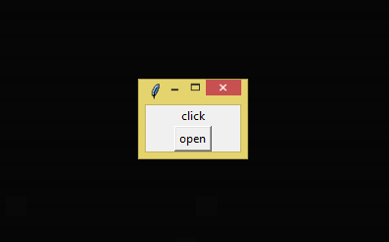SCREENSHOTS

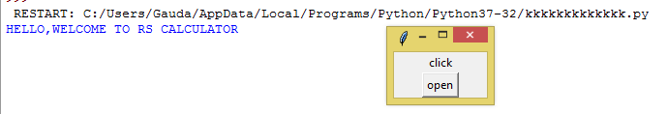

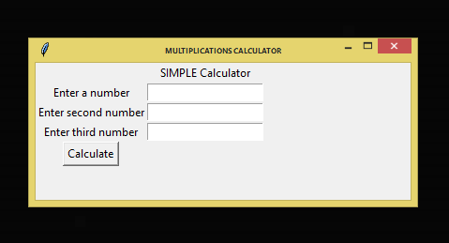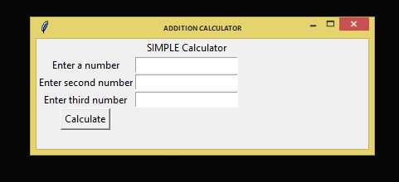

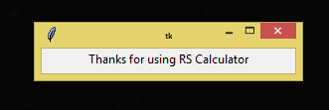

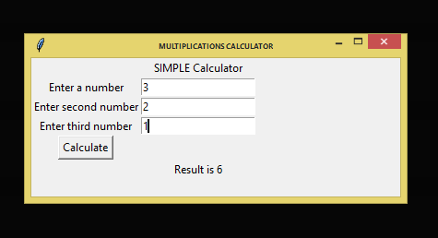 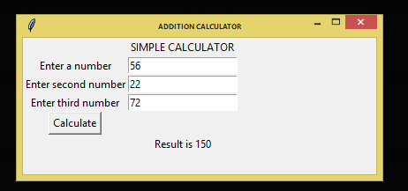

CONCLUSION

TKINTER IS EXCELLENT FOR SMALL , QUICK GUI APPLICATION, AND SINCE IT RUNS ON MORE PLATFORMS THAN ANY OTHER PYTHON GUI TOOLKIT , IT IS A GOOD CHOICE WHERE PORTABIITY IS THE PRIME CONCERN.

BIBLIOGRAPHY

* Wikipedia.org
* Google.com
* COMPUTER SCIENCE TEXTBOOK FOR CLASS 12 BY SUMITA ARRORA.

SYSTEM DESIGN

root. geometry() for size

tk. label () for labels

tk. entry() to read the input field

label. result label for calculate button

call_ result () to call the function

tk. Button () to place the button in the tkinter

root. mainloop () displays the window

tk.Entry() to create input field in the GUI

tk.stringvar() can easily monitor changes

to **tkinter** variables

INTRODUCTION

* THIS PROJECT IS AIMED TO CREATE A GUI BASED SIMPLE CALCULATOR USING PYTHON TKINTER MODULE.
* PYTHON WITH TKINTER OUTPUTS THE FASTEST AND EASIEST WAY TO CREATE THE GUI APPLICATION .
* CREATING GUI USING TKINTER IS EASY TASK.
* SIMPLE CALCULATOR CAN PERFORM BASIC ARITHMATIC OPERATIONS LIKE ADDITION MULTIPLICATION.
* SOMETIMES PEOPLE GET CONFUSED ABOUT THE RE CALCULATION SO HERE WE ARE PRESENTING SIMPLE CALCULATOR IN WHICH ALL TYPES OF CALCULATION CAN BE DONE WITHOUT GOING WRONG IN JUST A SECONDS.
* WE MADE THIS CALCULATOR FOR THE SHOPKEEPERS AS THEY HAVE TO PERFORM HUGE CALUCATION IN JUST SECONDS. SO THESE CALCULATORS WILL HELP THEM TO SAVE THEIR TIME AND MAKING THE CALCULATION EASY FOR THEM.